The tACS challenge: Does 10 Hz tACS rhythmically modulate visual perception in humans?

Til Ole Bergmann1,2*, Benedikt Zoefel3*, Christoph S. Herrmann4*, Ines R. Violante5*, Nir Grossman6,7*, Umair Hassan8,9*, Florian H. Kasten3*, Hartwig R. Siebner10,11,12*, Heiko I. Stecher4, Eleonora Marcantoni13, Prince Okyere14, Syanah C. Wynn1, Gemma Learmonth15, Danishta Kaul15, Hamzeh Norouzi15, Lorella Battelli16, Federica Contò16, Giulia Ellena16, Michele Tosi16, Jonathan M. Fawcett17, Benjamin Zendel17, Jovana Bjekić18, Saša Filipović18, Marko Živanović18,19, ChunLei Liu20, Silin Zhou20, Katherine Dyke21, Domenica Veniero21, Chang-Bing Huang22,23, Fang-Fan Yan22,23, Qingshang Ma22,23, Michele Scandola24, Gabriele Fusco25, Stella Petkovic25, Biagio Dell'Omo25, Salvatore Maria Aglioti25, Tino Zaehle26, Katharina Rufener26, Martin V. Sale27, Nicholas Bland27, Sanne ten Oever28, Inge Leunissen28, Teresa Schuhmann28, Alexander Sack28, Yuri G. Pavlov29, Dauren Kasanov30, Alexandra I. Kosachenko30, Lukas Diedrich31, Yong Jiang31,Lasse Christiansen10,32, Armita Faghani Jadidi10, Leo Tomasevic10, Mikkel M. Beck10, Ying Cai33, Hao Cui33, Yunn Qing Ang33, Christian Frings34, Malte Wöstmann35,36, Jonas Obleser35,36, Tobias Bäumer37, Elisa Martín-Arévalo38, Juan Lupiáñez38, Renato Ponce38, Matthias Mittner39, Gábor Csifcsák39, Josephine Groot39, Daria Antonenko40, Agnes Flöel40,41, Hannah Wagner-Gillen40, Jesús Cespón42,43,44, Susana Cid-Fernández43,44,45, Fernando Díaz42,43,44, Christopher Gundlach46, Gesa Hartwigsen46,47, Bernhard Sehm47, Alireza Gharabaghi48, David Menrath48, Joshua Woller48, Till R. Schneider49, Marina Fiene49, Jonas Misselhorn49, Philipp Ruhnau50, Chistopher C. Pack51, Matthew R. Krause51, Pedro G. Vieira51, Fabian Arteaga51, Luca Battaglini52, Giulio Contemori52, Miguel Castelo-Branco53, Catarina Duarte53, João Castelhano53, Andrew K. Martin54,55, Surjo Soekadar56, David Haslacher56, Annalisa Colucci56, Mareike Vermehren56, Niels Peekhaus56, Björn Apfel56, Khaled Nasr56, Vincent Jonany56, Lin He57,58, Qiang Gao57,58, Yu Hu59, Richard Ivry60, Philipp Reber60, Ludovica Labruna60, Christina Merrick60, Katheryn Thayer-Pham60, Andreas Jooß61, Nerea Ortiz de Zarate Garcia61, Ulf Ziemann61, Marta Bortoletto62, Vincenza Tarantino63, Silvio Ionta64, Antoni Valero-Cabré65, Carlo Leto65, Lucas Poux65, Nicolas Bruno65, Giuseppe Di Dona66, Sara Stottmeier67, Eduardo López-Candeda68, Alberto González-Villar68, Adriana Sampaio68, Yifan Shen13, Chaofan Kong13, Christopher Turner13, Mircea van der Plas13, Jonathan Howard6, Elena Tonolli69, Gregor Thut13*, Axel Thielscher10,70*, Edward Rhodes6,7*, Carlo Miniussi68*, Andrea Antal31*, Simon Hanslmayr13*

* Corresponding authors

1 Neuroimaging Center (NIC), Focus Programme Translational Neuroscience (FTN), Johannes Gutenberg University Medical Center Mainz, Germany

2 Leibniz Institute for Resilience Research (LIR), Mainz, Germany

3 University of Toulouse, CNRS, Centre de Recherche Cerveau et Cognition (CerCo), Toulouse, France

4 Carl von Ossietzky Universität Oldenburg, Department of Psychology, Germany

5 School of Biomedical Engineering and Imaging Sciences, King’s College London, London, United Kingdom

6 Department of Brain Sciences, Imperial College London, London, United Kingdom

7 UK Dementia Research Institute Imperial College London, United Kingdom

8 Department of Psychiatry and Behavioral Sciences, Stanford University, USA  
9 Wu Tsai Neurosciences Institute, Stanford University, USA

10 Danish Research Centre for Magnetic Resonance (DRCMR), Department of Radiology and Nuclear Medicine, Copenhagen University Hospital - Amager and Hvidovre, Denmark

11 Department of Neurology, Copenhagen University Hospital Bispebjerg and Frederiksberg, Denmark

12 Institute for Clinical Medicine, Faculty of Health Sciences and Medicine, University of Copenhagen, Denmark

13 School of Psychology and Neuroscience, Centre for Neurotechnology, University of Glasgow, Glasgow, UK

14 School of Psychology, University of Surrey, Guildford, UK

15 University of Stirling, Scotland, UK

16 Italian Institute of Technology, Italy

17 Memorial University of Newfoundland, St. John’s, NL, Canada

18 Human Neuroscience Group, Centre for Neuroscience and Neuromodulation, Institute for Medical Research, University of Belgrade, Serbia

19 Institute of Psychology, Department of Psychology, Faculty of Philosophy, University of Belgrade, Serbia

20 School of Psychology, Qufu Normal University, China

21 University of Nottingham, UK

22 Institute of Psychology, Chinese Academy of Sciences, Beijing, China

23 Department of Psychology, University of Chinese Academy of Sciences, Beijing, China

24 Department of Human Sciences, University of Verona, Italy

25 Department of Psychology, “Sapienza” University of Rome and CLN2S@SAPIENZA, Istituto Italiano di Tecnologia, Rome, Italy

26 Department of Neurology, University Magdeburg, Germany

27 School of Health and Rehabilitation Sciences, The University of Queensland, St Lucia, 4072, Australia

28 Department of Cognitive Neuroscience, Faculty of Psychology and Neuroscience, Maastricht University, The Netherlands

29 University of Tuebingen, Germany

30 Laboratory of Neurotechnology, Ural Federal University, Russia

31 NIBS lab, Department of Neurology, University Medical Center Göttingen, Germany

32 Institute for Neuroscience, Faculty of Health Sciences and Medicine, University of Copenhagen

33 Department of Psychology and Behavioral Science , Zhejiang University, China

34 University of Trier, Germany

35 Department of Psychology, University of Lübeck, Lübeck, Germany

36 Center of Brain, Behavior and Metabolism (CBBM), University of Lübeck, Lübeck, Germany

37 Institute of Systems Motor Science, University of Lübeck, Lübeck, Germany

38 Department of Experimental Psychology and Mind, Brain and Behavior Research Center (CIMCYC), University of Granada, Spain

39 Department of Psychology, UiT The Arctic University of Norway, Norway

40 Department of Neurology, Universitätsmedizin Greifswald, Germany

41 German Centre for Neurodegenerative Diseases (DZNE) Standort Greifswald, Greifswald, Germany

42 Department of Clinical Psychology and Psychobiology, University of Santiago de Compostela, Spain

43 NeuCoG-Aging Group, Instituto de Investigación en Psicoloxía (IPsiUS), University of Santiago de Compostela, Spain

44 Instituto de Investigación Sanitaria de Santiago de Compostela (IDIS), Spain

45 Department of Developmental and Educational Psychology, University of Santiago de Compostela, Spain

46 Wilhelm Wundt Institute for Psychology, Leipzig University, Germany

47 Max Planck Institute for Human Cognitive and Brain Sciences, Leipzig, Germany

48 Institute for Neuromodulation and Neurotechnology, University Tübingen, Germany

49 Dept. of Neurophysiology and Pathophysiology, University Medical Center Hamburg-Eppendorf, Germany

50 School of Psychology and Humanities, University of Central Lancashire, UK

51 Montreal Neurological Institute, McGill University, Canada

52 Department of General Psychology, University of Padova, Italy

53 CIBIT, ICNAS, Faculty of Medicine, University of Coimbra, Portugal

54 School of Psychology, University of Kent, UK

55 Kent Medway Medical School, UK

56 Clinical Neurotechnology Laboratory, Dept. of Psychiatry and Neurosciences, Charité Campus Mitte (CCM), Charité - Universitätsmedizin Berlin, Berlin, Germany

57 Key Laboratory of Rehabilitation Medicine in Sichuan Province, West China Hospital, Sichuan University, Chengdu, China

58 Department of Rehabilitation Medicine, West China Hospital, Sichuan University, Chengdu, China

59 Department of Rehabilitation Medicine, The Third People’s Hospital of Chengdu, The Affiliated Hospital of Southwest Jiaotong University, China

60 Departments of Psychology and Neuroscience, University of California, Berkeley, USA

61 Hertie Institute for Clinical Brain Research, Department Neurology and Stroke, University of Tübingen, Germany

62 IMT School For Advanced Studies Lucca, Lucca, Italy

63 Department of Psychology, Educational Science and Human Movement, University of Palermo, Italy

64 Sensory-Motor Laboratory, Department of Ophthalmology-University of Lausanne, Jules Gonin Eye Hospital-Fondation Asile des Aveugles, Lausanne, Switzerland

65 Causal Dynamics Plasticity and Rehabilitation Lab, FRONTLAB team, CNRS UMR 7225 INSERM 1127 Institut du Cerveau et la Moelle (ICM), Pitié-Salpêtrière Hospital and Sorbonne Université, Paris, France

66 Department of Psychology and Cognitive Science, University of Trento, Italy

67 School of Psychology, Vita-Salute San Raffaele University, Milan, Italy

68 Psychological Neuroscience Lab, Psychology Research Center (CIPsi), School of Psychology, University of Minho, Portugal

69 Center for Mind/Brain Sciences - CIMeC, University of Trento, Italy

70 Technical University of Denmark, Denmark

# Abstract

Transcranial alternating current stimulation (tACS) is a promising tool to non-invasively modulate rhythmic brain activity. Such a modulation allows interrogation of causal mechanisms underlying cognition and behaviour, or treatment of related conditions. However, the field is plagued by non-reproducible results, most likely driven by a combination of underpowered studies, publication bias, and inefficient designs, which lead some to question whether tACS is effective overall. This Registered Report represents a large-scale multi-centre effort to address these challenges. We will conduct a tACS experiment designed to stimulate the visual cortex to rhythmically modulate visual perception. Our design includes two active control conditions for peripheral nerve stimulation of the retina and skin, and a passive control condition. A confirmatory result would reveal rhythmic (i.e. phasic) modulation of perception during visual cortex stimulation, as well as a significant difference in rhythmic modulation strength or in the preferred phase angle between tACS and the two active control conditions.

# Introduction

Non-invasive brain stimulation is one of the fastest-growing fields in neurotechnology with important implications for academia, health, industry, and society. Transcranial alternating current stimulation (tACS), which injects weak currents into the brain to modulate its intrinsic rhythmic activity[1–3](https://www.zotero.org/google-docs/?X49b0k), has particular potential for developing low-cost treatments for psychiatric and neurological conditions (e.g., ADHD, PTSD, depression, Parkinson’s disease, dementia, chronic pain). Additionally, tACS holds potential for advancing our understanding of fundamental brain mechanisms by testing the causal role of brain oscillations in perceptual, cognitive, or motor functions[4,5](https://www.zotero.org/google-docs/?51136e). However, the field of tACS is plagued by ambiguous results, with some studies reporting evidence of tACS being effective in entraining neural activity and behaviour[6–11](https://www.zotero.org/google-docs/?iRz0f7), while others have contradicted or failed to replicate these findings[12–15](https://www.zotero.org/google-docs/?sAcFvU). This ambiguity is likely to be caused by a number of factors, for which the most relevant include: 1) small sample sizes in individual studies, which may lead to spurious positive findings and overestimated effect sizes, especially when combined with a bias to publish positive results[16,17](https://www.zotero.org/google-docs/?ZSZMBe); 2) the use of methodological designs that are inefficient to control for alternative explanations for the observed neural or behavioural effects of tACS, such as retinal or somatosensory co-stimulation[12,18](https://www.zotero.org/google-docs/?Daxzdn); 3) inadequate modelling of the current distribution. The goal of this registered report is to resolve the existing ambiguity regarding the hypothesised mechanism of action by investigating whether tACS-induced cortical stimulation can consistently induce a rhythmical modulation of visual performance in humans. This will be achieved by drastically increasing sample size, involving multiple laboratories, and by contrasting outcomes with those in two thoroughly designed peripheral control conditions informed by current distribution models.

TACS involves the application of weak sinusoidal currents to the scalp with an inversion of polarity (i.e., alternating current) and a balanced net current flow during the anodal and cathodal periods of stimulation during a sine cycle. These alternating currents are assumed to modulate neuronal membrane potentials, rhythmically shifting them towards and away from spontaneous firing thresholds. Thereby, tACS may mimic or entrain rhythmic brain activity and influence neural activity in the targeted brain regions[1](https://www.zotero.org/google-docs/?83x1CS). One significant biophysical challenge for tACS is that a substantial portion of the current is diverted through the skin and skull, resulting in a reduction of the electric field strength induced in the brain by approximately 20 to 100 times[19](https://www.zotero.org/google-docs/?rKpToE). Therefore, the amount of current that enters the brain is small, arguably much smaller than the currents that the brain generates itself[15](https://www.zotero.org/google-docs/?ApKMjH). Together, the low spatial resolution (i.e., low gradient of the electric field) and weak currents reaching the brain greatly affect the effectiveness of tACS in driving rhythmic brain activity. This leads to small effect sizes, which in turn highlights the need for large-sample data. It is important to note, however, that even though the weak electrical currents applied are unlikely to modulate the average firing rate of neurons, they can, if applied at conventional intensities used in humans, affect the timing of neural spiking and thereby influence rhythmic neural activity[10,11,20,21](https://www.zotero.org/google-docs/?LdWcmh).

Apart from these biophysical properties, unintended co-stimulation effects can lead to a modulation of neural activity or behaviour and may obscure the intended effects caused by direct cortical stimulation. Particularly, the injected currents can stimulate peripheral nerves or ganglion cells, which can lead to phosphenes[22,23](https://www.zotero.org/google-docs/?q1MFe8) and somatosensory stimulation[12](https://www.zotero.org/google-docs/?bGiBLP). Rhythmic activity from such peripheral stimulation then entrains cortical neurons, potentially explaining rhythmic effects on behaviour or neural activity. It is therefore important to control for such side effects to disambiguate direct neural effects of tACS from alternative indirect pathways. However, this is not trivial since direct and indirect effects occur at the same frequency (i.e., the frequency at which tACS is applied).

Oscillatory brain activity has been implicated in a plethora of perceptual, cognitive, and motor functions[24,25](https://www.zotero.org/google-docs/?JvR363). Neural oscillations in the alpha (8-14 Hz) band, most prominently expressed in occipital and parietal cortices, are of particular relevance to visual perception and attention. Initially described as an idling rhythm during eye closure or task disengagement[26](https://www.zotero.org/google-docs/?o3LQgf), its function has been refined over the last decades, assuming a more active role in gating visual perception and possibly even mediating visuospatial attention[27–30](https://www.zotero.org/google-docs/?ggiMga). Accordingly, both visual stimulus detection[31,32](https://www.zotero.org/google-docs/?W0rZK3) and phosphene thresholds[33](https://www.zotero.org/google-docs/?rkFOzA) are modulated by the phase of ongoing spontaneous alpha oscillations. This relationship between alpha phase and cortical excitability can be assessed via behavioural measures of visual detection and is thus a prime measure of tACS effects on neural activity and behaviour. In addition, the visual cortex is easy to target with tACS, and its occipital location allows comparably high stimulation intensities while minimising the likelihood of retinal phosphenes.

A previous study has already provided preliminary evidence that tACS at 10 Hz can modulate the likelihood of perceiving a visual stimulus in a phase-dependent manner[7](https://www.zotero.org/google-docs/?zzw9mZ). However, such alpha phase effects could not always be established in earlier work[34,35](https://www.zotero.org/google-docs/?KwwFtu). The combination of relatively small effect sizes and low participant numbers makes such null results difficult to interpret, as it remains unclear whether they are due to underpowered studies or reflect a “true” absence of tACS effects. We here tackle this question in a large-scale multi-centre study involving 45 labs collecting data from 880 participants. Specifically, we will apply tACS to target the visual cortex and test whether the likelihood of perceiving a visual stimulus is phasically modulated by the induced current. Our first hypothesis (#1 in Design Table) is a significant phasic modulation in the occipital tACS condition (Condition A), reflected in a z-score > 1.645 against a null distribution. A positive result would be supportive for the effectiveness of tACS in modulating behaviour, whereas a negative or null result would indicate absence of such evidence. Using Bayesian statistics, we will test for evidence in each direction (i.e. support in favour or against H1/H0).

We will contrast the phasic modulation of visual perception during occipital stimulation with that obtained in two active control conditions designed to produce equivalent retinal and somatosensory (i.e., cutaneous) stimulation, respectively, whilst not directly stimulating the brain. To this end, our second hypothesis (#2 in Design Table) is a significantly stronger phasic modulation (as measured by regression coefficients reflecting how strongly tACS phase predicts visual perception) in condition A (occipital tACS) than in conditions B (retinal tACS) and C (cutaneous tACS). If Condition A > B and Condition A > C, then we assume that 10 Hz tACS does rhythmically modulate visual perception by directly affecting currents in the brain, as opposed to stimulating peripheral nerves. If Condition A is not > B and A is not > C, then we assume that 10 Hz occipital tACS does not rhythmically modulate visual perception via directly affecting currents in the brain. If Condition A > B, and Condition A is not > C, then we can rule out peripheral stimulation of the retina contributing to the effect, but we cannot rule out stimulation of the skin driving the effect. Relatedly, if Condition A is not > B, and A > C, then we can rule out peripheral stimulation of the skin contributing to the effect, but we cannot rule out peripheral stimulation of the retina. Both of these outcomes would trigger an analysis of “preferred” phase angles (the tACS phase that leads to most detected targets; #3 in Design Table). If the difference in preferred phase angle between occipital and peripheral stimulation conditions is reliably different from 0, then we can rule out peripheral stimulation as a confounding factor. If no such difference emerges, we cannot rule out peripheral stimulation as a confounding factor. Again, we will use Bayesian statistics to test for evidence in each direction (i.e. support in favour or against H2 vs H0 and H3 vs H0).

An important question is if tACS stimulation entrains internal oscillations. Theoretical and empirical work suggests that entrainment is more effective when the stimulus frequency matches the internal frequency[36-39](https://www.zotero.org/google-docs/?KwwFtu). Therefore, we hypothesise to find a significant interaction between the difference of the individual alpha frequency and the fixed 10 Hz stimulation (delta IAF) and Condition (#4 in Design Table). If we find a significant interaction between delta IAF and Condition, and if this interaction is driven by stronger modulation of perception by delta IAF in the occipital tACS condition, then we conclude that tACS affects perception via entraining endogenous alpha oscillations. If no such interaction emerges then that would be absence of evidence for entrainment of such oscillations. We will use Baysian statistics to test for evidence in each direction (i.e. support in favour or against H4 vs H0).

Previous work suggested that increased alpha oscillations reflect inhibition and, in the visual cortex, diminish the ability to detect subtle visual stimuli28,40-42. We therefore hypothesise that occipital tACS (Condition A) modulates general measures of perception performance, regardless of phasic modulation (d-prime, response bias and reaction time; #5 in Design Table). If we find a main effect of condition and determine that this effect is driven by stronger modulation of general performance levels during the occipital tACS condition, we conclude that occipital tACS affects general levels of perception. If no main effect emerges, we would interpret this as absence of evidence for tACS modulating general levels of performance. Bayesian statistics will be applied to test for evidence in each direction (i.e. support in favour or against H5 vs H0).

Lastly, we also incorporate a passive sham control condition where no currents are induced to measure potential offline or after effects of tACS which could reflect other mechanisms of action (i.e. synaptic plasticity43). Regarding these after effects, we hypothesize to find a significant difference in general levels of performance in sham conditions (i.e. when no stimulation was applied) following the active stimulation conditions (#6 in Design Table). If we find a significant main effect of tACS condition, and/or interaction with delta IAF, and if we determine that this effect is driven by stronger after-effects following occipital tACS compared with the control conditions, we conclude that occipital 10 Hz tACS induces changes in brain activity that outlast the stimulation period itself. No significant main effect would indicate absence of evidence for tACS to induce effects beyond the stimulation period. Bayesian statistics will be applied to test for evidence in each direction (i.e. support in favour or against H6 vs H0).

Together, the inclusion effective control conditions, combined with the large sample size, enables us to draw reliable conclusions specifically on whether tACS with this particular montage is effective in modulating neural excitability in the occipital cortex and visual perception at the current intensities that are commonly used in humans.

# Methods

Ethical approval will be obtained by each participating lab in advance of data collection from the corresponding institutional review board (IRB) or the equivalent institutional committee responsible for research ethics. Ethical approval has already been granted for one site (University of Glasgow, School of Psychology and Neuroscience, Application Nr 200240302). All participants are required to provide written informed consent before any experimental procedures are conducted. Participants will receive compensation for their time according to their institution’s ethical approval.

**Participants**

Participants will be recruited from institution-managed participant databases or in response to study advertisements. Inclusion criteria include age (18-39 years), normal or corrected-to-normal vision and ability to give written and oral informed consent. Exclusion criteria include self-reported pregnancy, self-reported medical conditions which may interfere with the study (e.g., epilepsy, heart disease), previously diagnosed neurological or psychiatric condition, use of medication which may have cognitive effects (e.g., stimulants, antidepressants, neuroleptics), severe scalp skin lesions (i.e., razor nicks, wounds that have not healed, recent scar tissue, broken skin, etc.), previous craniotomy or other acute neurosurgical interventions, metal implants or electronic objects implanted in the upper part of the body (e.g., pacemaker, deep brain stimulator, cochlear implant), alcohol intake exceeding 28 units per week, smoking of more than 20 cigarettes per day, use of illicit substances in the week prior to the experimental session. Additional inclusion and exclusion criteria may be added depending on requirements from local committees for research ethics.

## Pilot data

Pilot data was collected to test the feasibility of the different components of the experimental protocol. Specifically, we tested (i) the feasibility of the visual detection task, (ii) feasibility of adjusting stimulation intensities based on phosphene/cutaneous sensations, and (iii) feasibility of acquiring a readout of the tACS phase from EEG electrodes placed on the scalp.

Concerning the visual detection task, we tested the implementation of the staircase procedure for individual titration of the target (i.e., LED) intensities (see Behavioural Task section) and performed the main task, without brain stimulation, in a sample of ten participants. Participants were healthy students recruited from the University of Oldenburg and had normal or corrected-to-normal vision. They performed 40 trials of the task to titrate the luminance of the target to reach 70.7% accuracy, using an adaptive staircase procedure (2 up, 1 down). Thereafter, participants performed 9 blocks of the visual detection task. The data from these pilots is shown in Figure 1 and suggests feasibility of the visual perception task.

Pilot data to test the procedure of adjusting the stimulation intensities due to phosphene/cutaneous sensations were acquired from another set of 4 healthy participants recruited at the Leibniz Institute for Resilience Research, Mainz. This data is reported in the section entitled transcranial alternating current stimulation.

Pilot data was also collected to test the feasibility of recording the tACS signal with conventional EEG electrodes positioned on the scalp. This data is reported in Figure 3B.

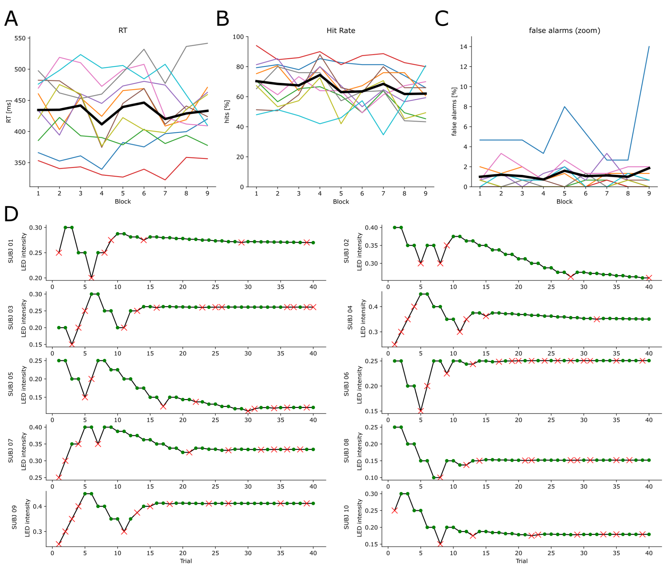

**Figure 1. Pilot recordings for the behavioural task (N = 10) .** The panels in (A-C) show reaction time **(A)**, hit rate **(B)** andfalse alarm rate **(C)** for the visual detection task across 9 blocks (x-axis) which was collected after individual titration. Each block consisted of 150 trials and the task was performed in absence of any electrical stimulation. Coloured lines indicate single subject performance. Black line indicates average across subjects. Overall performance measures appear to be relatively stable across blocks and on average hovers around ~75%. **(D)** Single trial data during the titration procedure is shown for individual participants. LED intensity (a.u.) is shown on the y-axis, and trial number on the x-axis. Green dots indicate hits, red crosses indicate missed targets.

## Design

**Experimental Procedure**

We will employ a multi-centre, within-subjects, peripheral-control experimental design. Each participant will take part in one experimental session lasting approximately 2.5 hours. The session is composed of five parts in the following order: 1) Informed consent and pre-stimulation questionnaires; 2) Training on the behavioural task and titration of the visual stimulus; 3) TACS setup and sensory thresholds; 4) Pre-stimulation resting state EEG recording; 5) Main behavioural task (with recording of reported perceptual sensations); 6) Post-stimulation resting state EEG; 7) Post-stimulation questionnaires.

**Behavioural Task**

Participants will perform a visual detection task in which they are asked to detect changes in brightness occurring in their lower left and right peri-foveal visual fields, which are more susceptible to tACS modulation that occurs in the upper visual cortex where the electric fields are stronger. The task is conducted under dimmed lighting conditions, with participants sitting comfortably in front of an LED array positioned at a distance of 1 m from their eyes (Figure 2A). The LED array is composed of five LEDs (3 mm diameter) located equidistantly in a U-shaped half circle at 0.7° (radius) visual angle eccentricity around a central white fixation LED. The fixation LED will never change its luminance. While all LEDs are continuously lit, any of the LEDs in the U-shaped half circle, but never more than one, can change their luminance for 10 ms without any preceding temporal or spatial cue. This change in LED luminance is the target stimulus. The interstimulus interval (ISI) will be sampled from a lognormal distribution with a minimum of 1.5 s and a maximum of 7 s to ensure unpredictability whilst keeping the duration of the experiment at a reasonable length. Thus, the mean ISI will be ~ 2.8 s with a standard deviation of around 0.7 s. Such randomised stimulation ensures that the onsets of target stimuli are equally distributed across the tACS phases. Participants are instructed to fixate on the central LED, avoid excessive blinking, and press a button with the index finger of the dominant hand whenever they detect a target. Responses are collected using a custom-made button-box.

Hits will be calculated as the number of button presses occurring in a time window from 150 to 1200 ms after the target. Consequently, if no button press occurs within that time window, this will be counted as a miss. If multiple button presses occur, the first one will be counted. Button presses which are not preceded by a target 1200 ms prior to the button press, will be counted as false alarms (FAs). In total, 450 targets will be presented for each active stimulation condition, whereas a total of 200 targets (50 per block) will be presented for the passive sham control (fewer trials are needed to assess general performance in comparison to phasic effects). This adds up to ~21 min per active stimulation montage (tACS, retinal control, cutaneous control; described below), that is ~7 min per block (9 blocks), and ~10 minutes for the passive sham control (~2.3 minutes per block), resulting in ~72 min total task time plus breaks (between runs). Visual target intensity (i.e., intensity of transient luminance increase) will be titrated to 70.7% accuracy (i.e., hit rate) for each participant using an adaptive staircase procedure (2 up, 1 down) with 40 trials. The procedure will start with a large luminance change of the target LED (from 20% to 40% of the max LED voltage). A 5% change in intensity translates to a change of ~4.3 lux (as measured with a sensor placed 1 cm from the LED). The luminance change will then be decreased by a factor of two with each reversal. Reversal refers to a change in the direction of luminance changes (e.g., from decreasing to increasing values) that follows on a respective response (e.g., an incorrect response). The luminance change will be increased by factor two if no reversal occurs for more than 2 trials.

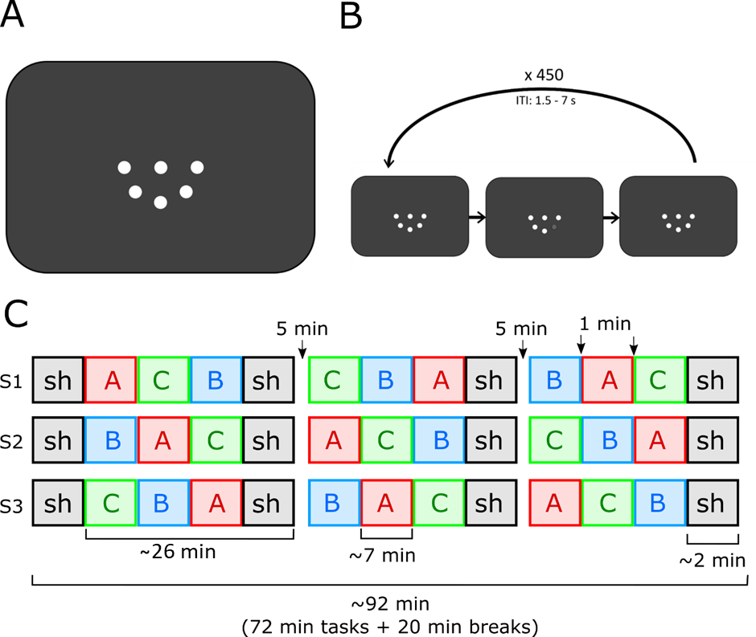

**Figure 2. Visual perception task and procedure. (A)** Stimulus design and **(B)** example timeline for a single experimental trial. **(C)** The sequence of conditions and the counterbalancing procedure is illustrated. Blocks A, B, and C refer to the three electrode montages/conditions (i.e., A = occipital tACS, B = retinal control stimulation, and C = cutaneous control stimulation), whilst sh refers to the passive sham control during which no tACS stimulation will be applied. The sequence of A, B and C will be counterbalanced using a latin square procedure across participants, where one third of participants will receive the condition as shown in sequence 1 (S1), another third as shown in S2, and the rest as per S3. The position of the passive sham control will always stay the same. This allows testing for after effects, and to control for potential order effects, whilst maintaining the same mean position between conditions.

**Transcranial alternating current stimulation (tACS)**

TACS will be delivered using standard devices available at participating labs. A fixed frequency of 10 Hz will be employed across the three different montages (A = occipital tACS; B = retinal control stimulation; C = cutaneous control stimulation; sh = passive sham stimulation). TACS will be delivered in 9 blocks (7 min each, with 1 second ramping up/down periods at the beginning and end of each block), 3 per montage condition, in balanced order (with a random permutation of the Latin Square for each subject, e.g., ACB CBA BAC; cf. Figure 2C). Four blocks of a passive sham control during which no currents are injected will be carried out at the start and after every third block (see Figure 2C). In between blocks, short breaks (~1 min) will be made, during which stimulation parameters and cabling will be adapted. Moreover, the participant will be able to take a longer (self-paced, but minimum 5 min) break after the second, and third sham stimulation block. Double-blinding will inherently exist for phase. Additional blinding is achieved through a second experimenter responsible for performing any manual montage switching procedures. This ensures that neither the montage hardware switch itself nor the control software is visible to the experimenter interacting with the participant or to the participant themselves. However, participants may still notice differences in perceptual sensations. All tACS intensity values are provided as peak-to-peak amplitudes in µA.

**Occipital tACS (Condition A):** This montage is designed to obtain a relatively homogeneous current distribution in the left and right occipital cortices, with very little current being shunted via the eyeballs and retina. Three round rubber electrodes with 2.5 cm diameter will be placed at locations O1, Oz, and O2 (according to the 10-20 International System) and physically connected before plugging them into the “negative pole” of the stimulator channel, while three larger round rubber electrodes with 4.5 cm diameter will be placed at locations CPz, CP5, and CP6, physically linked and connected to the “positive” pole of the stimulator channel. Linking of stimulation electrodes will be done via (a) Y-link cables, or custom built (b) passive or (c) active montage switching devices (different linking strategies are not expected to have a significant impact on current distribution and are an option to reduce the timings associated with cable switching). Stimulation intensity will be set to 90% of the individual phosphene threshold (PT) or 90% of the individual threshold for rhythmic cutaneous sensations (non-rhythmic cutaneous sensations are acceptable) for this montage, whatever is lower. To determine the stimulation intensity, the experimenter will apply short stimulations of 5 s each and manually increase intensities from 1000 µA in steps of 50 µA until the subject indicates the target sensation (phosphene or rhythmic cutaneous sensation). The stimulation intensity will then be increased one step further to ensure a clear sensation and then reduced again in steps of 25 µA until no perception is left. The last intensity value with a sensation is accepted as threshold, and 90% thereof (or the next lower value that is possible to select at the specific device) will be used as stimulation intensity for this montage. Piloting data suggests that for this montage (without the use of a local anaesthetic cream; see below) the rhythmic cutaneous sensation threshold will be lower (at ~1700-2125 µA; based on N = 4 subjects) than the phosphene threshold (see Figure 3A for details).

The occipital tACS condition will be contrasted against two control conditions which have been designed to control for peripheral stimulation effects, whilst not inducing meaningful current in the brain. To this end, they resemble passive control conditions in that they do not directly stimulate the brain. Furthermore, the control conditions are designed not to elicit consciously perceivable rhythmic sensations that may mask rhythmic effects induced by the occipital tACS condition, while providing an effective control for subliminally induced rhythmic sensations.

**Retinal control stimulation (Condition B):** Thismontage has been optimised to stimulate the retina of both eyes without significantly stimulating the brain transcranially.Two round rubber electrodes with 2.5 cm diameter will be placed on the cheek under the left and right eyes, physically linked together and connected to the “negative” pole of the stimulator channel, while the three linked larger round rubber electrodes with 4.5 cm diameter at locations CPz, CP5, and CP6 will be connected to the “positive” pole of the stimulator channel. Using the same titration procedure as described above (for Condition A, but starting at 100 µA and increasing/decreasing in steps of 25 µA), stimulation intensity will be set to 90% of the individual PT or 90% of the individual threshold for rhythmic cutaneous sensations (non-rhythmic cutaneous sensations are acceptable) for this montage, whatever is lower. Pilot data suggests that for this montage (without the use of local anaesthetic cream) the PT will be reached (at ~150-300 µA; based on N = 4 subjects) before the rhythmic cutaneous sensation threshold can be reached (see Figure 3B for details).

**Cutaneous control stimulation (Condition C):** Thismontage has been optimised to stimulate peripheral nerves in the skin underneath the occipital electrodes. The round 2.5 cm diameter electrode over Oz will be connected to the “positive” pole of the stimulator channel, while the same sized electrodes at locations O1 and O2 will be physically linked and connected to the “negative” pole of the stimulator channel. Thus, the majority of the current is shunted through the skin, while only strongly reduced currents reach the brain transcranially. Using the same titration procedure as described above (for Condition A), stimulation intensity will be set to 90% of the individual threshold for rhythmic cutaneous sensations (non-rhythmic cutaneous sensations typically associated with electrical stimulation are deemed acceptable and not taken into account for this threshold) or 90% of the individual PT for this montage, whatever is lower. Pilot data suggests that for this montage (without the use of local anaesthetic cream) the rhythmic cutaneous sensation threshold will be reached (at ~1400-1700 µA; based on N = 4 subjects) before the PT can be reached (see Figure 3C for details).

**Passive sham control:** A passive sham control condition will be conducted to test for general performance levels when no currents are injected via the tACS electrodes. This allows to compare the generic (phase-independent) effects of the other active stimulation conditions (A, B, and C) against a no-stimulation baseline, as well as testing for potential after effects outlasting the online stimulation effects.

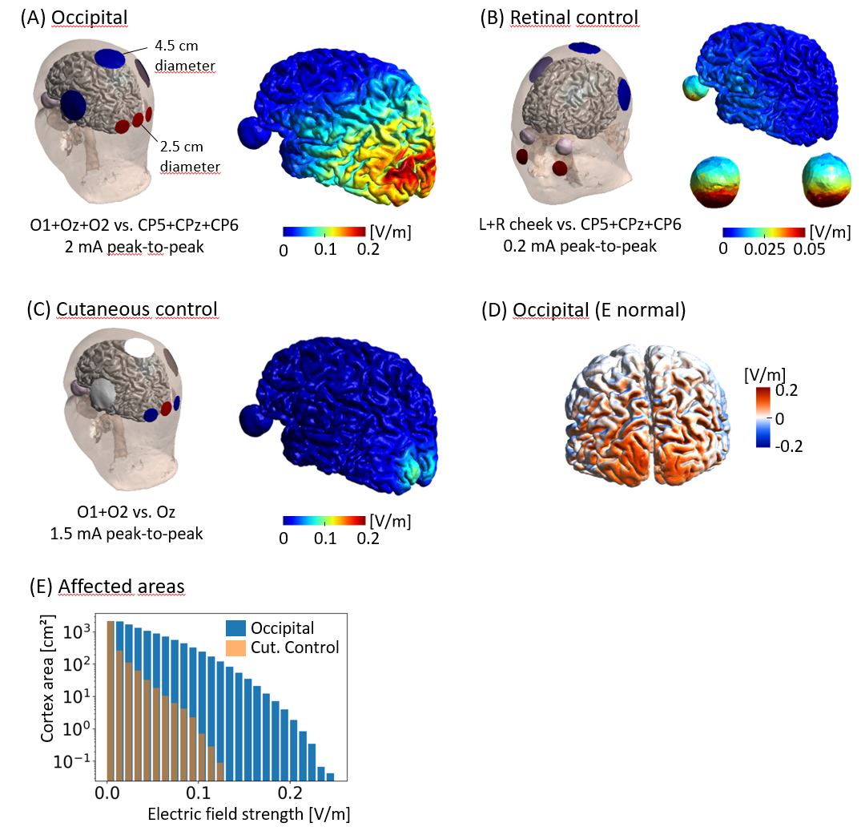

**Figure 3. Electrode montages and electric field distributions for the three tACS conditions.** The current intensity values for the simulations were selected according to the average intensities obtained in the pilot subjects for the three experimental conditions. **(A)** Occipital tACS: Channel 1 is connected to the neighbouring electrodes O1, Oz & O2, channel 2 connected to the three more distributed electrodes CP5, CPz & CP6. This focusses the electric field in early visual areas and decreases it in anterior areas, helping to prevent phosphene induction. Peak electric field strength in grey matter: 0.20 V/m (99.9%ile, evaluated on the central gray matter surfaces that are situated halfway between the white-grey matter boundary and the pial surface). **(B)** Retinal control: Two small electrodes on the cheeks are connected to channel 1 and the three electrodes CP5, CPz & CP6 to channel 2. This leads to strong electric fields in the eyes for efficient retinal stimulation at low current intensities. Peak field strength in gray matter: 0.02 V/m. **(C)** Cutaneous control: Electrode Oz is connected to channel 1 and electrodes O1 and O2 to channel 2. The current flows predominantly in the scalp area surrounding the three electrodes while being weak in the brain. Peak field strength in gray matter: 0.09 V/m. **(D)** Occipital tACS: Visualisation of the electric field component that is oriented orthogonal to the cortical sheet. The large area with homogenous red colour around the occipital poles indicates a homogenous in-phase stimulation of the early visual areas. **(E)** Cortical surface areas affected by the occipital tACS and cutaneous control conditions. The cumulative histograms show the cortical surface areas that experience at least the electric field strength depicted on the x-axis. For example, the area receiving 0.1 V/m or more is 242 cm² for occipital tACS, while it is smaller than 1 cm² for the cutaneous control condition. All simulations were performed using SimNIBS 4 and the SimNIBS example dataset “ernie”.

**Electrode positioning**

Textile landmark caps with fitted 3D printed cap electrode holders will be positioned on the participants’ heads according to their head size (Figure 4). The holders were designed to prevent bridging of the occipital electrodes and facilitate standardised electrode positioning. Before electrode application, participants’ hair will be combed in a concentric fashion from the centre of the electrode position outwards and skin will be cleaned using alcohol and abrasive gel (with subsequent removal of remaining gel with alcohol and hair drying). The stimulation electrodes (2 mm thick, with the plug connector in the centre; e.g., NeuroCare - www.neurocaregroup.com) will be affixed to the scalp through the holders using conductive Ten20 paste (e.g., Unimed Electrode Supplies Inc.) about 3 mm thick. To minimise induced sensations and impedance, a tubular net-shaped elastic bandage in mesh tissue will be placed on top of the electrodes on the head, providing a uniform electrode-skin contact (Figure 4B). Electrodes’ impedances will be measured and recorded for each montage at the beginning (i.e., before the start of the first block) and at the end of the experiment (i.e., after the last block). Measuring impedances of electrodes is important because it will affect the distribution of the induced current and can lead to asymmetries (e.g., if the impedance between O1 and CP5 is much higher than the impedance between CP6 and O2, less current will be induced in the left hemisphere). To account for this potential confound, impedances will be measured for the following pairs: O1 - Oz, O2 - Oz, CP5 - O1, CP6 - O2, left eye - CP5, and right eye - CP6 and used as a covariate in statistical analysis (see below).

**Stimulation waveform recording**

The stimulation waveform will be recorded with conventional Ag/AgCl electrodes used for EEG with 10 mm diameter and 1.5 mm touch proof connector to connect to the device input. This is necessary to determine the phase of the tACS signal at the time of target presentation (see Figure 4C). The input signal is not amplified, and is digitised with a 1 kHz sampling rate. To avoid any DC offset there is a 0.07 Hz high-pass filter. In addition, the circuit is designed to protect both the device and user from electrostatic discharge. To prevent overloading the 3.3 V power supply, a 3.3 V Zener diode is positioned at the amplifier output. This clips any voltage greater than 3.3 V. The device has a BNC connector that can be used to send a short square-pulse trigger up to 5 V. This trigger will be used to communicate with the tACS stimulator and begin stimulation.

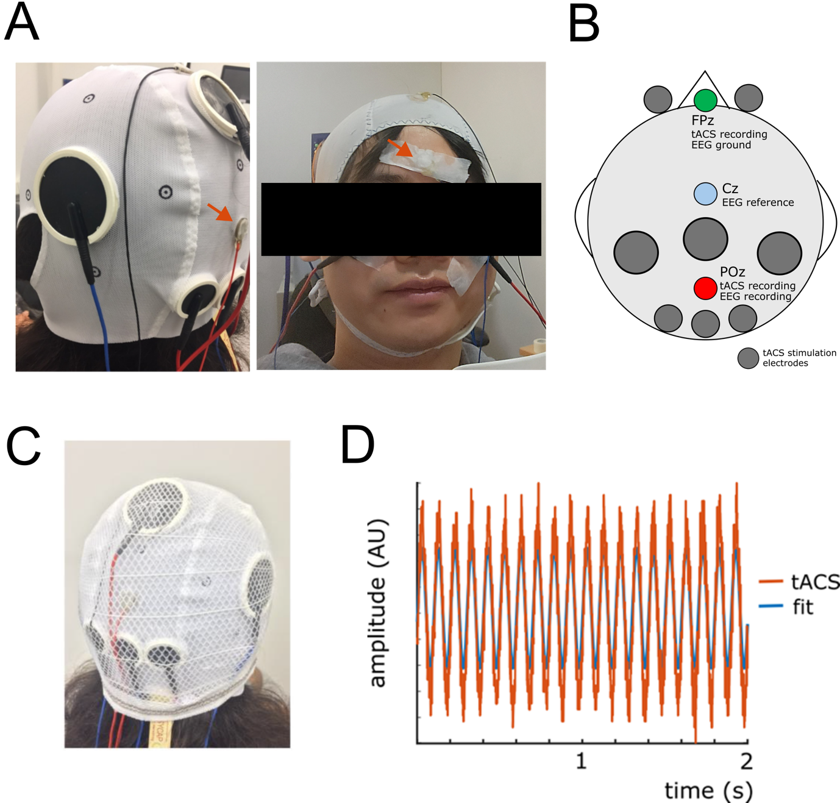

**Figure 4. Custom-made caps for tACS and recording electrodes. (A)** A custom-made cap is shown with the tACS electrodes and conventional EEG electrodes used to measure the tACS signal. Red arrows point out the electrodes recording the tACS signal: FPz, and reference electrode: POz. **(B)** **A** schematic for the montage is shown. The green circle highlights the recording electrode for the tACS signal (FPz), which is also used as a ground for the EEG recordings. The light blue circle highlights the electrode used as a reference for the EEG recording only (Cz), and the red circle shows the reference electrode for the tACS signal recording, and for recording EEG. **(C)** The montage is shown with the tubular net-shaped elastic bandage in place. **(D)** The tACS signal recorded with the EEG electrodes and its 10-Hz sinusoidal fit (blue). The phase of the sinusoid will be used for further analyses.

**EEG resting state recordings**

Resting state EEG will be recorded from the same electrode pair that is used to record the tACS signal. To this end, the two electrodes at POz and Cz will be connected to a conventional EEG amplifier using Cz as a reference and FPz as Ground. The EEG will be sampled at a minimum of 100 Hz, during 2 minutes eyes-open and 2 minutes eyes-closed resting state. These resting state EEG data will be recorded before the start of the experiment, and after the experiment, but before the post-stimulation questionnaires are given. The purpose of the pre-experimental EEG recording is to be able to determine the individual alpha frequency (IAF), and use it as a covariate in data analysis. The purpose of the post-experimental resting state EEG recording is to examine the data for potential offline effects in exploratory analyses. Out of the 43 data collecting labs, 40 labs have the necessary equipment to record EEG which leads to a total sample size of N=800.

**Topical application of anaesthetic cream:** Labs which are willing and able to apply a local anaesthetic cream will use it in order to decrease skin sensation and pain, effectively allowing for higher stimulation intensities12, while limiting maximum current intensity at 2000 µA (peak-to-peak amplitude). Labs using the anaesthetic cream will follow the same standard operating procedure to ensure methodological standardisation. In brief, the skin will be anaesthetised using topical anaesthetic cream (10 mg of cream with the following active ingredients: 25 mg/g Lidocaine + 25 mg/g prilocaine; e.g., EMLA cream or a generic brand). The cream will be applied to the skin using a syringe to bypass the hair and then distributed manually (wearing rubber gloves) at the areas where the 6 cortical stimulation electrodes will be placed (i.e., O1, Oz, O2, CP5, CPz, CP6). The anaesthetic will be applied to the skin using a diameter that is 2 cm larger than the diameter of the electrode (i.e., 4.5 cm for the 2.5 cm electrodes) to ensure sufficient numbing around the rim of the electrode, where current densities are strongest. After an exposure time of 60 min, the anaesthetic cream will be washed off, and the hair and skin dried thoroughly using a hair dryer. Labs which cannot use local anaesthetic cream will perform the experiments without it (with potentially lower stimulation intensity).

**Brain stimulation questionnaires**

Before administration of tACS, participants will complete the screening questionnaire for low intensity transcranial electrical stimulation (tES), which includes a question on participants’ experience of receiving brain stimulation44 in the past and to check for contra-indications against the local anaesthetic cream, if used. After each block, participants will complete a questionnaire to assess the presence of tACS related sensations on a 10-point Likert scale, including the perception of phosphenes, skin sensations, pain, metallic taste, and dizziness or nausea (see Supplemental Materials).

### Sampling plan

Each lab will be asked to recruit 20 participants yielding eligible data points. Eligible means that there were no technical issues affecting the running of the experiment. Only datasets where the experiment was completed in full will be used. Datasets where the experiment needed to be aborted, either due to technical issues or because of issues affecting the participants ability to continue will not be eligible for analysis and will be replaced. In total, this will yield a total sample size of 880 eligible data points (with 44 labs collecting data). Inclusion and exclusion criteria are described above (participant section).

Based on previous studies, and the collective experience of the authors, we assume that the effect size will be small. Expressed in Cohen’s d that would mean an effect size of around 0.2[45,46](https://www.zotero.org/google-docs/?KwwFtu). With a sample size of 880 we would be able to detect an effect size as small as 0.11 with a power of 0.95, based on calculations using G* Power[47](https://www.zotero.org/google-docs/?KwwFtu) for paired-samples and one-sample t-tests.

## Analysis Plan

**tACS Phase Effects**

The tACS signal applied will be estimated from an EEG electrode located in proximity to the tACS electrodes (Figure 4A). The “true” tACS phase will be extracted by fitting a sine function at the stimulation frequency (10 Hz) to the recorded signal. This fit will also account for slight variations in stimulation frequency (+/- 0.001 Hz) that can occur. We have verified in preliminary tests that this is feasible and robust against noise (Figure 4C).

Once tACS phases have been extracted for each of the presented targets, we will quantify how strongly they can predict target detection in the different conditions. To do so, we will use a model that regresses single-trial outcomes onto tACS phase using a logistic (for dichotomous response variables, e.g. hit rates) or linear (for continuous response variables, e.g., reaction times) regression (i.e., so that no binning of data is required). This method was among the most sensitive to detect phasic modulation of behaviour in a recent simulation study48. It returns a regression coefficient that reflects the magnitude of phasic modulation for each subject and for each experimental condition. This coefficient will be used for group analyses as described next.

To test whether the phasic modulation is statistically reliable in a given condition, we will simulate a null distribution of these regression coefficients by randomly assigning tACS phases to targets before re-computing the regression coefficients. By repeating this permutation procedure 1000 times (separately for each subject and condition), we will obtain a distribution of coefficients that would be obtained in the absence of a phasic effect. The “true” regression coefficient will be compared with the null distribution to obtain group-level statistical (z-) scores, according to Equation 1:

$z = (d-μ) / σ$ 1

where z reflects the group level effect in the observed data, d is the regression coefficient, averaged across subjects in the observed data, and μ and σ are mean and standard deviation (across permutations) of the subject-averaged regression coefficient in the surrogate distribution, respectively. The phasic modulation observed will be considered reliable if the z-score exceeds a critical value (z = 1.645, corresponding to a significance threshold of α = 0.05, one-tailed).

Our hypothesis predicts a statistically reliable phasic modulation in the occipital tACS condition (as compared to the null distribution), reflected in a z-score >= 1.645 as described above.

To contrast phasic effects between conditions, we will use two dependent samples t-tests contrasting the “true” regression coefficients (d) between the occipital stimulation condition against each of the two control conditions (p-level will be corrected accordingly). In addition, a linear mixed model will quantify the effect of condition and other factors on the obtained regression coefficients. This model includes individual participants, sequence of conditions, and the testing lab identity as random effects, and the following fixed effects: condition (occipital tACS, cutaneous control, retinal control), stimulation intensity, hemispheric impedance difference, gender, age (5 year bracket), use of local anaesthetics (EMLA) and Individual Alpha Frequency (IAF; see below). Our hypothesis predicts phasic modulation to be significantly larger for the occipital tACS condition than for the cutaneous and retinal control conditions. In addition, to test whether the order of conditions has an explicit effect on the phasic modulation of behaviour, we will also run another linear mixed model where sequence of conditions is added as a fixed effect instead of a random effect.

Previous studies demonstrated that weak stimulation methods are more likely to entrain brain rhythms that match the stimulation frequency. Therefore, we will test whether any effect of tACS phase on perception is mediated by Individual Alpha Frequency (IAF) in the linear mixed model described above. To estimate IAF we will use a fully automated approach that has been validated and shown to perform well even in scenarios with low signal-to-noise ratios and which outperforms manual estimations of IAF49. The processing pipeline is available for MNE Python and Matlab and therefore can be used by all participating labs to calculate IAF consistently and objectively (<https://github.com/corcorana/restingIAF?tab=readme-ov-file>). We will use the peak-alpha-frequency (PAF) from the eyes-closed condition as an indicator for IAF, allowing for a frequency range of 7-13 Hz as recommended in Corcoran et al.49. Finally, we will compute the absolute difference between IAF and 10 Hz, termed *delta IAF*. If tACS acts via entraining endogenous rhythms through direct injection of electrical currents in the brain, we expect to see a significant effect of *delta IAF*, and interaction between *delta IAF* and Condition (showing stronger modulation of perception for the occipital stimulation condition).

We will also extract the tACS phase that leads to the highest proportion of detected targets (the “preferred” tACS phase) in each condition. This will allow us to test whether the conditions differ in their individual preferred phase (circular one-sample test against an angle of 0 for the circular difference in preferred phase between conditions for individual subjects). The latter is another important control to distinguish between cortical and retinal or cutaneous effects: If potential phasic modulations in the tACS occipital condition were exclusively driven by retinal or cutaneous stimulation, then the preferred phase in that condition should be similar to that found in the retinal or cutaneous condition. This analysis will be triggered if we find no significant difference between condition A (occipital tACS) and any of the two control conditions (retinal or cutaneous stimulation, i.e., condition B and C, respectively). Our hypothesis therefore predicts different preferred phases in the tACS occipital and the retinal control condition.

We will conclude that tACS reliably modulates visual detection if one of the following is true: a) statistically reliable phasic modulation in the occipital tACS condition, and stronger phasic modulation in the occipital tACS condition than in the control conditions; b) statistically reliable phasic modulation in the occipital tACS condition, and difference in preferred phase between tACS occipital and retinal or cutaneous conditions. We further conclude that tACS reliably modulates visual detection via entrainment of internal oscillations if phasic modulation in the occipital tACS condition is statistically reliably mediated by *delta IAF*, as indicated by a *delta IAF* by condition interaction in the linear mixed effects model.

**tACS effects on general levels of performance and after effects**

To assess the effects of tACS on general levels of performance we will run a linear mixed model with individual participants, sequence of conditions and the testing lab identity as random effects, and the following fixed effects: condition (occipital tACS, cutaneous control, retinal control, and passive sham), stimulation intensity, hemispheric impedance difference, gender, age (5 year bracket), use of local anaesthetics (EMLA) and Individual Alpha Frequency (IAF). Significant main effects for condition, and interactions with IAF, intensity, or EMLA, will be followed up with post-hoc comparisons. Following previous studies, showing that alpha oscillations have an inhibitory effect on visual processing, we hypothesise that the occipital tACS condition leads to reduced perception performance compared to the passive sham control condition. Given that the two active control stimulation conditions may also influence alpha activity via retinal or somato-sensory stimulation we remain agnostic as to whether significant differences with respect to general levels of performance between these two active control conditions and the occipital tACS condition will emerge. In addition, to test whether the order of conditions has an explicit effect on behavioural after effects, we will also run another linear mixed model where sequence of conditions is added as a fixed effect instead of a random effect.

Lastly, to test for potential after effects (i.e. offline effects) of tACS we will run another linear mixed model on the visual perception performance data in the passive sham condition only. Random effects will be individual participants, sequence of conditions, and the testing lab and fixed effects will be: tACS condition (pre, post-occipital tACS, post-cutaneous control, post-retinal control), stimulation intensity, hemispheric impedance difference, gender, age (5 year bracket), use of local anaesthetics (EMLA) and Individual Alpha Frequency (IAF). Significant main effects for condition, and interactions with IAF, intensity or EMLA, will be followed up with post-hoc comparisons. Following previous studies, showing after effects of 10 Hz tACS on alpha oscillations we hypothesise to find significant differences between post-occipital and the first sham run, as well as post-occipital and the two active control conditions (post-retinal, and post-cutaneous). As above, we will also run another linear mixed model where sequence of conditions is added as a fixed effect instead of a random effect to allow us to explicitly investigate any potential effects of order.

## In addition to frequentist statistics we will also employ Bayesian statistics, in particular we will calculate the Bayes Factor to assess the evidence for the Null / Alternative hypothesis.

# Data availability

Information about the initiative, with links to data and code can be found at the tACS Challenge website (<https://tacschallenge.github.io/>). Data will be made publicly available on <https://osf.io/gz84a/>.

# Code availability

All source code used in this study, including scripts for extraction of relevant parameters from data files and different analytical steps, is available via the following repository: <https://github.com/tACSChallenge>.

# Results

Do **not** include a **Results** section.

# Discussion

Do **not** include a **Discussion** section.

# References

[1. Antal, A. & Herrmann, C. S. Transcranial Alternating Current and Random Noise Stimulation: Possible Mechanisms. *Neural Plasticity* **2016**, e3616807 (2016).](https://www.zotero.org/google-docs/?bzPL2h)

[2. Herrmann, C. S., Rach, S., Neuling, T. & Strüber, D. Transcranial alternating current stimulation: a review of the underlying mechanisms and modulation of cognitive processes. *Front. Hum. Neurosci.* **7**, (2013).](https://www.zotero.org/google-docs/?bzPL2h)

[3. Hanslmayr, S., Axmacher, N. & Inman, C. S. Modulating Human Memory via Entrainment of Brain Oscillations. *Trends in Neurosciences* **42**, 485–499 (2019).](https://www.zotero.org/google-docs/?bzPL2h)

[4. Bergmann, T. O. & Hartwigsen, G. Inferring Causality from Noninvasive Brain Stimulation in Cognitive Neuroscience. *Journal of Cognitive Neuroscience* **33**, 195–225 (2021).](https://www.zotero.org/google-docs/?bzPL2h)

[5. Thut, G., Miniussi, C. & Gross, J. The Functional Importance of Rhythmic Activity in the Brain. *Current Biology* **22**, R658–R663 (2012).](https://www.zotero.org/google-docs/?bzPL2h)

[6. Fiene, M. *et al.* Phase-specific manipulation of rhythmic brain activity by transcranial alternating current stimulation. *Brain Stimulation* **13**, 1254–1262 (2020).](https://www.zotero.org/google-docs/?bzPL2h)

[7. Helfrich, R. F. *et al.* Entrainment of brain oscillations by transcranial alternating current stimulation. *Curr Biol* **24**, 333–339 (2014).](https://www.zotero.org/google-docs/?bzPL2h)

[8. Herring, J. D., Esterer, S., Marshall, T. R., Jensen, O. & Bergmann, T. O. Low-frequency alternating current stimulation rhythmically suppresses gamma-band oscillations and impairs perceptual performance. *NeuroImage* **184**, 440–449 (2019).](https://www.zotero.org/google-docs/?bzPL2h)

[9. van Bree, S., Sohoglu, E., Davis, M. H. & Zoefel, B. Sustained neural rhythms reveal endogenous oscillations supporting speech perception. *PLOS Biology* **19**, e3001142 (2021).](https://www.zotero.org/google-docs/?bzPL2h)

[10. Krause, M. R., Vieira, P. G., Csorba, B. A., Pilly, P. K. & Pack, C. C. Transcranial alternating current stimulation entrains single-neuron activity in the primate brain. *Proceedings of the National Academy of Sciences* **116**, 5747–5755 (2019).](https://www.zotero.org/google-docs/?bzPL2h)

[11. Vieira, P. G., Krause, M. R. & Pack, C. C. tACS entrains neural activity while somatosensory input is blocked. *PLoS Biol* **18**, e3000834 (2020).](https://www.zotero.org/google-docs/?bzPL2h)

[12. Asamoah, B., Khatoun, A. & Mc Laughlin, M. tACS motor system effects can be caused by transcutaneous stimulation of peripheral nerves. *Nat Commun* **10**, 266 (2019).](https://www.zotero.org/google-docs/?bzPL2h)

[13. Liu, A. *et al.* Immediate neurophysiological effects of transcranial electrical stimulation. *Nat Commun* **9**, 5092 (2018).](https://www.zotero.org/google-docs/?bzPL2h)

[14. Lafon, B. *et al.* Low frequency transcranial electrical stimulation does not entrain sleep rhythms measured by human intracranial recordings. *Nat Commun* **8**, 1199 (2017).](https://www.zotero.org/google-docs/?bzPL2h)

[15. Vöröslakos, M. *et al.* Direct effects of transcranial electric stimulation on brain circuits in rats and humans. *Nat Commun* **9**, 483 (2018).](https://www.zotero.org/google-docs/?bzPL2h)

[16. Minarik, T. *et al.* The Importance of Sample Size for Reproducibility of tDCS Effects. *Front Hum Neurosci* **10**, 453 (2016).](https://www.zotero.org/google-docs/?bzPL2h)

[17. Brown, A. W., Mehta, T. S. & Allison, D. B. Publication Bias in Science: What Is It, Why Is It Problematic, and How Can It Be Addressed? in *The Oxford Handbook of the Science of Science Communication* (eds. Jamieson, K. H., Kahan, D. M. & Scheufele, D. A.) 0 (Oxford University Press, 2017). doi:10.1093/oxfordhb/9780190497620.013.10.](https://www.zotero.org/google-docs/?bzPL2h)

[18. Schutter, D. J. L. G. Cutaneous retinal activation and neural entrainment in transcranial alternating current stimulation: A systematic review. *NeuroImage* **140**, 83–88 (2016).](https://www.zotero.org/google-docs/?bzPL2h)

[19. Miranda, P. C., Lomarev, M. & Hallett, M. Modeling the current distribution during transcranial direct current stimulation. *Clin Neurophysiol* **117**, 1623–1629 (2006).](https://www.zotero.org/google-docs/?bzPL2h)

[20. Tran, H., Shirinpour, S. & Opitz, A. Effects of transcranial alternating current stimulation on spiking activity in computational models of single neocortical neurons. *Neuroimage* **250**, 118953 (2022).](https://www.zotero.org/google-docs/?bzPL2h)

[21. Johnson, L. *et al.* Dose-dependent effects of transcranial alternating current stimulation on spike timing in awake nonhuman primates. *Science Advances* **6**, eaaz2747 (2020).](https://www.zotero.org/google-docs/?bzPL2h)

[22. Kar, K. & Krekelberg, B. Transcranial electrical stimulation over visual cortex evokes phosphenes with a retinal origin. *J Neurophysiol* **108**, 2173–2178 (2012).](https://www.zotero.org/google-docs/?bzPL2h)

[23. Laakso, I. & Hirata, A. Computational analysis shows why transcranial alternating current stimulation induces retinal phosphenes. *J Neural Eng* **10**, 046009 (2013).](https://www.zotero.org/google-docs/?bzPL2h)

[24. Buzsáki, G. & Draguhn, A. Neuronal oscillations in cortical networks. *Science* **304**, 1926–1929 (2004).](https://www.zotero.org/google-docs/?bzPL2h)

[25. Schroeder, C. E. & Lakatos, P. Low-frequency neuronal oscillations as instruments of sensory selection. *Trends Neurosci.* **32**, 9–18 (2009).](https://www.zotero.org/google-docs/?bzPL2h)

[26. Berger, H. Über das Elektrenkephalogramm des Menschen. *Archiv f. Psychiatrie* **87**, 527–570 (1929).](https://www.zotero.org/google-docs/?bzPL2h)

[27. VanRullen, R. Perceptual Cycles. *Trends Cogn. Sci. (Regul. Ed.)* **20**, 723–735 (2016).](https://www.zotero.org/google-docs/?bzPL2h)

[28. Jensen, O. & Mazaheri, A. Shaping Functional Architecture by Oscillatory Alpha Activity: Gating by Inhibition. *Front Hum Neurosci* **4**, (2010).](https://www.zotero.org/google-docs/?bzPL2h)

[29. Jensen, O., Gips, B., Bergmann, T. O. & Bonnefond, M. Temporal coding organized by coupled alpha and gamma oscillations prioritize visual processing. *Trends in Neurosciences* **37**, 357–369 (2014).](https://www.zotero.org/google-docs/?bzPL2h)

[30. Hanslmayr, S., Gross, J., Klimesch, W. & Shapiro, K. L. The role of alpha oscillations in temporal attention. *Brain Research Reviews* **67**, 331–343 (2011).](https://www.zotero.org/google-docs/?bzPL2h)

[31. Busch, N. A., Dubois, J. & VanRullen, R. The Phase of Ongoing EEG Oscillations Predicts Visual Perception. *J. Neurosci.* **29**, 7869–7876 (2009).](https://www.zotero.org/google-docs/?bzPL2h)

[32. Mathewson, K. E., Gratton, G., Fabiani, M., Beck, D. M. & Ro, T. To See or Not to See: Prestimulus α Phase Predicts Visual Awareness. *J Neurosci* **29**, 2725–2732 (2009).](https://www.zotero.org/google-docs/?bzPL2h)

[33. Dugué, L., Marque, P. & VanRullen, R. The Phase of Ongoing Oscillations Mediates the Causal Relation between Brain Excitation and Visual Perception. *J. Neurosci.* **31**, 11889–11893 (2011).](https://www.zotero.org/google-docs/?bzPL2h)

[34. Keitel, C., Ruzzoli, M., Dugué, L., Busch, N. A. & Benwell, C. S. Y. Rhythms in cognition: The evidence revisited. *European Journal of Neuroscience* **55**, 2991–3009 (2022).](https://www.zotero.org/google-docs/?bzPL2h)

[35. Ruzzoli, M., Torralba, M., Morís Fernández, L. & Soto-Faraco, S. The relevance of alpha phase in human perception. *Cortex* **120**, 249–268 (2019).](https://www.zotero.org/google-docs/?bzPL2h)

36[. Notbohm, A., Kurths, J. & Herrmann, C. S. Modification of Brain Oscillations via Rhythmic Light Stimulation Provides Evidence for Entrainment but Not for Superposition of Event-Related Responses. Front Hum Neurosci 10, 10 (2016).](https://www.zotero.org/google-docs/?bzPL2h)

[37. Hanslmayr, S., Matuschek, J. & Fellner, M.-C. Entrainment of prefrontal beta oscillations induces an endogenous echo and impairs memory formation. Curr Biol 24, 904–909 (2014).](https://www.zotero.org/google-docs/?bzPL2h)

[38. L’Hermite, S. & Zoefel, B. Rhythmic Entrainment Echoes in Auditory Perception. J. Neurosci. 43, 6667–6678 (2023).](https://www.zotero.org/google-docs/?bzPL2h)

[39. Huang, W. A. et al. Transcranial alternating current stimulation entrains alpha oscillations by preferential phase synchronization of fast-spiking cortical neurons to stimulation waveform. Nat Commun 12, 3151 (2021).](https://www.zotero.org/google-docs/?bzPL2h)

40[. Hanslmayr, S. et al. Prestimulus oscillations predict visual perception performance between and within subjects. Neuroimage 37, 1465–1473 (2007).](https://www.zotero.org/google-docs/?bzPL2h)

[41. Balestrieri, E. & Busch, N. A. Spontaneous Alpha-Band Oscillations Bias Subjective Contrast Perception. J Neurosci 42, 5058–5069 (2022).](https://www.zotero.org/google-docs/?bzPL2h)

[42. Klimesch, W., Sauseng, P. & Hanslmayr, S. EEG alpha oscillations: The inhibition–timing hypothesis. Brain Research Reviews 53, 63–88 (2007).](https://www.zotero.org/google-docs/?bzPL2h)

43[. Vossen, A., Gross, J. & Thut, G. Alpha Power Increase After Transcranial Alternating Current Stimulation at Alpha Frequency (α-tACS) Reflects Plastic Changes Rather Than Entrainment. *Brain Stimul* **8**, 499–508 (2015).](https://www.zotero.org/google-docs/?bzPL2h)

44[. Antal, A. *et al.* Low intensity transcranial electric stimulation: Safety, ethical, legal regulatory and application guidelines. *Clin Neurophysiol* **128**, 1774–1809 (2017).](https://www.zotero.org/google-docs/?bzPL2h)

45[. Solla, F., Tran, A., Bertoncelli, D., Musoff, C. & Bertoncelli, C. M. Why a P-Value is Not Enough. *Clin Spine Surg* **31**, 385–388 (2018).](https://www.zotero.org/google-docs/?bzPL2h)

46[. Kang, H. Sample size determination and power analysis using the G*Power software. *J Educ Eval Health Prof* **18**, 17 (2021).](https://www.zotero.org/google-docs/?bzPL2h)

[47. Faul, F., Erdfelder, E., Lang, A.-G. & Buchner, A. G*Power 3: a flexible statistical power analysis program for the social, behavioral, and biomedical sciences. *Behav Res Methods* **39**, 175–191 (2007).](https://www.zotero.org/google-docs/?bzPL2h)

[48. Zoefel, B., Davis, M. H., Valente, G. & Riecke, L. How to test for phasic modulation of neural and behavioural responses. *NeuroImage* **202**, 116175 (2019).](https://www.zotero.org/google-docs/?bzPL2h)

[49. Corcoran, A. W., Alday, P. M., Schlesewsky, M. & Bornkessel-Schlesewsky, I. Toward a reliable, automated method of individual alpha frequency (IAF) quantification. *Psychophysiology* **55**, e13064 (2018).](https://www.zotero.org/google-docs/?bzPL2h)

# Acknowledgements

The authors received no specific funding for this work.

# Author contributions

tACS Steering Committee (<https://tacschallenge.github.io/coreteam/>) AA, TOB, NG, SH, UH, CH, FK, CM, HRS, ER, AT, GT, IRV, BZ, and MvdP, ET project planning, project management, experimental design, development of devices, piloting, data analysis, writing and editing of draft, collecting data for stage 2 registered report. All other authors: editing of draft and collecting data for stage 2 registered report.

# Competing interests

A.A. has received consulting fees from Neurocare (Germany), from Savir GmbH, (Germany), and from Elsevier, she is a paid advisor by Electromedical Products International (USA), has received equipment support from Sooma. She is a member of the advisory board of PlatoScience. She is the Vice President of the European Brain Stimulation Society and member at the Europa, Middle East, Africa Chapter of the International Federation of ClinicalNeurophysiology. C.S.H holds a patent on brain stimulation and cooperates with Klaus Schellhorn, the CEO of Neuroconn GmbH (Ilmenau, Germany). S.H. is a scientific advisor to Clarity Technologies Inc. of which he owns shares. R.I. and C.M. are co-founders with equity in Magnetic Tides, Inc. and K.T.P. is an employee of Magnetic Tides with equity.

# Table 1. Design Table

|  |  |  |  |  |
| --- | --- | --- | --- | --- |
| **Question** | **Hypothesis** | **Sampling plan (e.g. power analysis)** | **Analysis Plan** | **Interpretation given to different outcomes** |
| # 1:  Does occipital 10 Hz tACS rhythmically modulate visual perception (accuracy or reaction time)? | Significantly greater phasic modulation in the occipital tACS condition (Condition A) than in a null distribution, reflected in a z-score > 1.645. | With an N=880 we can detect effect sizes as small as 0.11, which can be considered a weak effect. | Null distribution will be generated from permuted data (see Methods) to obtain a mean and standard deviation of regression coefficients (target detection regressed on tACS phase) under the null hypothesis. The average regression coefficient in the observed data will be expressed relative to the null distribution as a z-score, and interpreted as significant if >1.645 (p<0.05; one-tailed).  Using Bayesian statistics, we will test for evidence in each direction (i.e. support in favour or against H1/H0). | If z > 1.645 then occipital 10 Hz tACS rhythmically modulates visual perception. Such an outcome would trigger the analysis # 2 below.  If z < 1.645 then 10 Hz occipital tACS does not rhythmically modulate visual perception.  Strength of evidence will be determined by Bayesian statistics (range between anecdotal and very strong evidence for H0 or H1). |
| # 2:  Does occipital 10 Hz tACS rhythmically modulate visual perception (accuracy or reaction time) when controlling for peripheral stimulation effects? | Significantly stronger phasic modulation (as measured by regression coefficients) in condition A (occipital tACS) than in conditions B (retinal tACS) and C (cutaneous tACS). | With an N=880 we can detect effect sizes as small as 0.11, which can be considered a weak effect. | If the above randomization test results in z > 1.645, then we will conduct two paired-samples t-tests, one-tailed, corrected for multiple comparisons (N=2), i.e. the Bonferroni corrected p-level is 0.05 / 2 → p<0.025.  Using Bayesian statistics, we will test for evidence in each direction (i.e. support in favour or against H2/H0). | If Condition A > B and Condition A > C, then we assume that 10 Hz tACS does rhythmically modulate visual perception by directly affecting currents in the brain, as opposed to stimulating peripheral nerves.  If Condition A is not > B and A is not > C, then we assume that 10 Hz occipital tACS does not rhythmically modulate visual perception via directly affecting currents in the brain.  If Condition A > B, and Condition A is not > C, then we can rule out peripheral stimulation of the retina contributing to the effect, but we cannot rule out stimulation of the skin driving the effect. Such an outcome would trigger the analysis # 3 below.  If Condition A is not > B, and A > C, then we can rule out peripheral stimulation of the skin contributing to the effect, but we cannot rule out peripheral stimulation of the retina. Such an outcome would trigger the analysis # 3 below.  Strength of evidence will be determined by Bayesian statistics (range between anecdotal and very strong evidence for H0 or H2). |
| # 3:  Does occipital 10 Hz tACS rhythmically modulate visual perception (accuracy or reaction time) when controlling for peripheral stimulation effects? | Significant difference in preferred phase between occipital tACS stimulation and peripheral control stimulation (condition B or C). | With an N=880 we can detect effect sizes as small as 0.11, which can be considered a weak effect. | This analysis will be triggered by one of the following outcomes for analysis # 2:  Condition A > B, but not A > C.  Condition A > C, but not A > B.  Individual circular differences in “preferred” tACS phases (leading to highest target detection probability / faster RTs) between conditions will be extracted (condition A vs B and/or A vs C, whichever does not show a difference in analysis # 2) and compared against 0 (circular one-sample test against angle of 0). Bonferroni correction will be applied if two tests are carried out.  Using Bayesian statistics, we will test for evidence in each direction (i.e. support in favour or against H3/H0). | If the difference in preferred phase angle is reliably different from 0, then we can rule out peripheral stimulation as a confounding factor.  If no such difference emerges, we cannot rule out peripheral stimulation as a confounding factor.  Strength of evidence will be determined by Bayesian statistics (range between anecdotal and very strong evidence for H0 or H3). |
| # 4:  Does occipital 10 Hz tACS rhythmically modulate visual perception (accuracy or reaction time) via entraining internal oscillations? | Significant interaction between fixed effects *delta IAF* and Condition in linear mixed-effects model. | With an N=880 we can detect effect sizes as small as 0.11, which can be considered a weak effect. | Linear mixed model with individual participants, sequence of conditions, and the testing lab identity as random effects, and the following fixed effects: condition (occipital tACS, cutaneous control, retinal control), stimulation intensity, hemispheric impedance difference, gender, age (5 year bracket), use of local anaesthetics (EMLA) and Individual Alpha Frequency (IAF). We will also run another linear mixed model where sequence of conditions is added as a fixed effect instead of a random effect.  Using Bayesian statistics, we will test for evidence in each direction (i.e. support in favour or against H4/H0). | If we find a significant interaction between delta IAF and Condition, and if this interaction is driven by stronger modulation of perception by delta IAF in the occipital tACS condition, we conclude that tACS affects perception via entraining endogenous alpha oscillations.  Strength of evidence will be determined by Bayesian statistics (range between anecdotal and very strong evidence for H0 or H4). |
| # 5:Does occipital 10 Hz tACS modulate general levels of performance, as indicated by d-prime, response bias and RT? | Significant main effect of tACS Condition in linear mixed-effects model. | With an N=880 we can detect effect sizes as small as 0.11, which can be considered a weak effect. | Linear mixed model with individual participants, sequence of conditions, and the testing lab identity as random effects, and the following fixed effects: condition (occipital tACS, cutaneous control, retinal control, and passive sham control), stimulation intensity, hemispheric impedance difference, gender, age (5 year bracket), use of local anaesthetics (EMLA) and Individual Alpha Frequency (IAF). We will also run another linear mixed model where sequence of conditions is added as a fixed effect instead of a random effect.  Using Bayesian statistics, we will test for evidence in each direction (i.e. support in favour or against H5/H0). | If we find a main effect of condition and determine that this effect is driven by stronger modulation of general performance levels during the occipital tACS condition and if for #1 z < 1.645, we conclude that tACS affects perception in the absence of phase dependency.  Strength of evidence will be determined by Bayesian statistics (range between anecdotal and very strong evidence for H0 or H5). |
| # 6: Does occipital 10 Hz tACS induce after effects in general levels of performance as indicated by d-prime, response bias and RT? | Significant main effect of tACS Condition in linear mixed-effect model. | With an N=880 we can detect effect sizes as small as 0.11, which can be considered a weak effect. | Linear mixed model with individual participants, sequence of conditions, and the testing lab as random effects and tACS condition (pre, post-occipital tACS, post-cutaneous control, post-retinal control), stimulation intensity, hemispheric impedance difference, gender, age (5 year bracket), use of local anaesthetics (EMLA) and Individual Alpha Frequency (IAF) as fixed effects. We will also run another linear mixed model where sequence of conditions is added as a fixed effect instead of a random effect.  Using Bayesian statistics, we will test for evidence in each direction (i.e. support in favour or against H6/H0). | If we find a significant main effect for tACS condition, and/or interaction with delta IAF, and if we determine that this effect is driven by stronger after-effects following occipital tACS compared with the other control conditions, we conclude that occipital 10 Hz tACS induces changes in brain activity that outlast the stimulation period itself.  Strength of evidence will be determined by Bayesian statistics (range between anecdotal and very strong evidence for H0 or H6). |

# Supplementary information

Please see the Supplementary Information file.